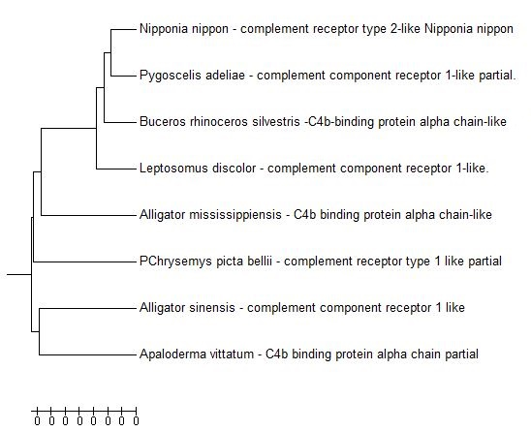**Figure. Evolutionary relationships of taxa**

The evolutionary history was inferred using the UPGMA method [1]. The optimal tree with the sum of branch length = 2,11727140 is shown. The tree is drawn to scale, with branch lengths in the same units as those of the evolutionary distances used to infer the phylogenetic tree. The evolutionary distances were computed using the Poisson correction method [2] and are in the units of the number of amino acid substitutions per site. The analysis involved 8 amino acid sequences. All positions containing gaps and missing data were eliminated. There were a total of 186 positions in the final dataset. Evolutionary analyses were conducted in MEGA7 [3].

1. Sneath P.H.A. and Sokal R.R. (1973). Numerical Taxonomy. Freeman, San Francisco.

2. Zuckerkandl E. and Pauling L. (1965). Evolutionary divergence and convergence in proteins. Edited in Evolving Genes and Proteins by V. Bryson and H.J. Vogel, pp. 97-166. Academic Press, New York.

3. Kumar S., Stecher G., and Tamura K. (2016). MEGA7: Molecular Evolutionary Genetics Analysis version 7.0 for bigger datasets.Molecular Biology and Evolution 33:1870-1874.

**Disclaimer:** Although utmost care has been taken to ensure the correctness of the caption, the caption text is provided "as is" without any warranty of any kind. Authors advise the user to carefully check the caption prior to its use for any purpose and report any errors or problems to the authors immediately (www.megasoftware.net). In no event shall the authors and their employers be liable for any damages, including but not limited to special, consequential, or other damages. Authors specifically disclaim all other warranties expressed or implied, including but not limited to the determination of suitability of this caption text for a specific purpose, use, or application.